

Online Shopping Management System
Course Name:
Database Systems
Developed By:
Muhammad Bin Rashid 70151094
Muhammad Ali Rashid 70176517
Abdurehman khan 70139031
Muhammad Tayyab 70143210
Submitted to:
Ms. Ambreen Akmal

1. Project Scenario
The rapid growth of e-commerce has increased the demand for efficient systems capable of managing large volumes of customer, product, and transaction data. Traditional manual methods of maintaining records are often inefficient, error-prone, and difficult to manage as business operations expand. Therefore, organizations require a reliable database system to store, organize, and retrieve information effectively.
The proposed Online Shopping Management System is designed to manage the core data and operations of an online retail business. The system maintains records related to customers, product categories, products, shopping carts, orders, and payments. It provides a structured approach for storing and managing data while ensuring accuracy, consistency, and integrity.
The database enables customers to register, place orders, and maintain purchase records, while administrators can manage products, categories, inventory information, and customer orders. The system ensures that all business transactions are properly recorded and that relationships between different data entities are maintained through primary and foreign key constraints.
The project emphasizes the application of relational database concepts and best practices. The database design is developed using Entity Relationship Modeling and Relational Schema Design. Normalization techniques are applied to eliminate redundancy and improve data consistency. Various SQL operations, including queries, views, triggers, and stored procedures, are implemented to support efficient data management and business processes.
The database consists of multiple related entities, including Customer, Category, Product, Cart, CartItem, Orders, OrderDetails, Payment, and Admin. These entities are interconnected through well-defined relationships that support the operational requirements of an online shopping environment.
The successful implementation of this project demonstrates the practical application of database management principles in a real-world scenario and provides an efficient, reliable, and scalable solution for managing online shopping data.

2. System Features

2.1 Customer Management
The system shall maintain customer information and records.

Features
- Store Customer Information
- Update Customer Records
- Retrieve Customer Information
- Maintain Customer Registration Data

2.2 Product Management
The system shall maintain product-related information.

Features
- Store Product Information
- Update Product Records
- Delete Product Records
- Maintain Product Inventory
- Store Product Pricing Information
- Store Product Descriptions

2.3 Category Management
The system shall organize products into categories.

Features
- Store Category Information
- Update Category Records
- Delete Category Records
- Associate Products with Categories

2.4 Shopping Cart Management
The system shall maintain shopping cart records.

Features
- Store Cart Information
- Associate Products with Shopping Carts
- Maintain Product Quantities
- Retrieve Cart Data

2.5 Order Management
The system shall maintain customer order information.

Features
- Store Order Records
- Maintain Order Details
- Track Order Status
- Retrieve Order Information
- Maintain Order History

2.6 Payment Management
The system shall maintain payment-related information.

Features
- Store Payment Records
- Maintain Payment History
- Track Payment Status
- Associate Payments with Orders

2.7 Administrator Management
The system shall maintain administrator records and system control information.

Features
- Store Administrator Information
- Manage Product Records
- Manage Category Records
- Monitor Order Information
- Maintain Inventory Records

2.8 Database Management Features
The system shall implement relational database concepts to ensure efficient data management.

Features
- Primary Key Constraints
- Foreign Key Constraints
- Entity Relationship Modeling
- Relational Schema Design
- Database Normalization (Up to Third Normal Form)
- SQL Query Processing
- Database Views
- Database Triggers
- Stored Procedures
- Data Integrity Enforcement
- Data Consistency Management
- Referential Integrity Management

2.9 Reporting and Data Retrieval
The system shall support retrieval and analysis of stored information.

Features
- Customer Information Reports
- Product Information Reports
- Category Reports
- Order Reports
- Payment Reports
- Inventory Reports

Summary
The Online Shopping Management System provides the following core functionalities:
- Customer Management
- Product Management
- Category Management
- Shopping Cart Management
- Order Management
- Payment Management
- Administrator Management
- Database Management
- Reporting and Data Retrieval

3. Required Tables
The Online Shopping Management System requires the following database tables to store and manage information efficiently.
Table Name | Purpose
Customer | Stores customer information such as name, email, phone number, and address.
Category | Stores product category information.
Product | Stores product details including name, description, price, stock quantity, and category.
Cart | Stores shopping cart information for customers.
CartItem | Stores products added to shopping carts along with quantities.
Orders | Stores customer order information.
OrderDetails | Stores details of products included in each order.
Payment | Stores payment information and transaction status.
Admin | Stores administrator information for system management.

Table Descriptions

Customer
Stores customer-related information.
Attributes:
- CustomerID (Primary Key)
- Name
- Email
- Password
- Phone
- Address
- RegistrationDate

Category
Stores product categories.
Attributes:
- CategoryID (Primary Key)
- CategoryName
- Description

Product
Stores product information.
Attributes:
- ProductID (Primary Key)
- CategoryID (Foreign Key)
- ProductName
- Description
- Price
- StockQuantity
- ImageURL

Cart
Stores shopping cart information.
Attributes:
- CartID (Primary Key)
- CustomerID (Foreign Key)
- CreatedDate

CartItem
Stores products added to shopping carts.
Attributes:
- CartItemID (Primary Key)
- CartID (Foreign Key)
- ProductID (Foreign Key)
- Quantity

Orders
Stores order information.
Attributes:
- OrderID (Primary Key)
- CustomerID (Foreign Key)
- OrderDate
- TotalAmount
- OrderStatus

OrderDetails
Stores detailed information about products included in orders.
Attributes:
- OrderDetailID (Primary Key)
- OrderID (Foreign Key)
- ProductID (Foreign Key)
- Quantity
- UnitPrice

Payment
Stores payment records.
Attributes:
- PaymentID (Primary Key)
- OrderID (Foreign Key)
- PaymentMethod
- PaymentDate
- Amount
- PaymentStatus

Admin
Stores administrator information.
Attributes:
- AdminID (Primary Key)
- Name
- Email
- Password

Primary Keys and Foreign Keys

Primary Keys
- CustomerID
- CategoryID
- ProductID
- CartID
- CartItemID
- OrderID
- OrderDetailID
- PaymentID
- AdminID

Foreign Keys
- Product.CategoryID → Category.CategoryID
- Cart.CustomerID → Customer.CustomerID
- CartItem.CartID → Cart.CartID
- CartItem.ProductID → Product.ProductID
- Orders.CustomerID → Customer.CustomerID
- OrderDetails.OrderID → Orders.OrderID
- OrderDetails.ProductID → Product.ProductID
- Payment.OrderID → Orders.OrderID

4. Database Normalization

4.1 Introduction
Normalization is the process of organizing data in a database to reduce redundancy and improve data integrity. The Online Shopping Management System database is normalized up to Third Normal Form (3NF) to ensure efficient data storage and consistency.

4.2 Unnormalized Form (UNF)
Initially, all information may be stored in a single table containing repeating groups and redundant data.
CustomerID | CustomerName | ProductID | ProductName | Category | Quantity | OrderID | PaymentMethod
1 | Ali Khan | 101 | Formal Shirt | Men | 2 | 5001 | Cash
1 | Ali Khan | 102 | Denim Jeans | Men | 1 | 5001 | Cash
2 | Sara Ahmed | 103 | Kurti | Women | 1 | 5002 | Card

Problems in UNF
- Data redundancy
- Duplicate customer information
- Duplicate product information
- Update anomalies
- Insert anomalies
- Delete anomalies

4.3 First Normal Form (1NF)
To achieve First Normal Form:
- Remove repeating groups.
- Ensure each attribute contains atomic values.
- Ensure each record is unique.

Customer Table
CustomerID | Name | Email | Phone
1 | Ali Khan | ali@example.com | 03001234567
2 | Sara Ahmed | sara@example.com | 03111234567

Product Table
ProductID | ProductName | Category | Price
101 | Formal Shirt | Men | 2500
102 | Denim Jeans | Men | 3500
103 | Kurti | Women | 2800
Result:
- Repeating groups removed.
- Atomic values ensured.

4.4 Second Normal Form (2NF)
To achieve Second Normal Form:
- Database must already be in 1NF.
- Remove partial dependencies.
- Non-key attributes must depend on the entire primary key.

Orders Table
OrderID | CustomerID | OrderDate
5001 | 1 | 2025-06-01
5002 | 2 | 2025-06-02

OrderDetails Table
OrderDetailID | OrderID | ProductID | Quantity | UnitPrice
1 | 5001 | 101 | 2 | 2500
2 | 5001 | 102 | 1 | 3500
3 | 5002 | 103 | 1 | 2800
Result:
- Partial dependencies removed.
- Order information separated from product details.

4.5 Third Normal Form (3NF)
To achieve Third Normal Form:
- Database must already be in 2NF.
- Remove transitive dependencies.
- Non-key attributes should depend only on the primary key.

Category Table
CategoryID | CategoryName | Description
1 | Men | Men's Clothing
2 | Women | Women's Clothing

Product Table
ProductID | CategoryID | ProductName | Price
101 | 1 | Formal Shirt | 2500
102 | 1 | Denim Jeans | 3500
103 | 2 | Kurti | 2800
Result:
- Category information stored separately.
- Product table references Category table through a Foreign Key.
- Transitive dependencies eliminated.

4.6 Final Normalized Tables (3NF)
- Customer
- Category
- Product
- Cart
- CartItem
- Orders
- OrderDetails
- Payment
- Admin

4.7 Benefits of Normalization
- Reduces data redundancy.
- Improves data consistency.
- Prevents update anomalies.
- Prevents insertion anomalies.
- Prevents deletion anomalies.
- Improves database integrity.
- Simplifies database maintenance.

5. Relationships Between Tables
The Online Shopping Management System database is normalized up to Third Normal Form (3NF). The following relationships are established between the normalized tables using Primary Keys and Foreign Keys to maintain data integrity and consistency.

5.1 Customer – Cart Relationship

Relationship Type
One-to-One (1:1)

Description
Each customer is associated with one shopping cart, and each shopping cart belongs to only one customer.

Foreign Key
Cart.CustomerID → Customer.CustomerID

5.2 Customer – Orders Relationship

Relationship Type
One-to-Many (1:M)

Description
A customer can place multiple orders, while each order belongs to only one customer.

Foreign Key
Orders.CustomerID → Customer.CustomerID

5.3 Category – Product Relationship

Relationship Type
One-to-Many (1:M)

Description
A category can contain multiple products, while each product belongs to only one category.

Foreign Key
Product.CategoryID → Category.CategoryID

5.4 Cart – CartItem Relationship

Relationship Type
One-to-Many (1:M)

Description
A shopping cart may contain multiple products. Each item in the cart is stored as a separate record in the CartItem table.

Foreign Key
CartItem.CartID → Cart.CartID

5.5 Product – CartItem Relationship

Relationship Type
One-to-Many (1:M)

Description
A product may appear in multiple shopping carts.

Foreign Key
CartItem.ProductID → Product.ProductID

5.6 Orders – OrderDetails Relationship

Relationship Type
One-to-Many (1:M)

Description
An order may contain multiple products. The OrderDetails table stores individual products associated with each order.

Foreign Key
OrderDetails.OrderID → Orders.OrderID

5.7 Product – OrderDetails Relationship

Relationship Type
One-to-Many (1:M)

Description
A product can appear in multiple orders placed by different customers.

Foreign Key
OrderDetails.ProductID → Product.ProductID

5.8 Orders – Payment Relationship

Relationship Type
One-to-One (1:1)

Description
Each order has one corresponding payment record, and each payment record is associated with a single order.

Foreign Key
Payment.OrderID → Orders.OrderID

5.9 Relationship Summary
Parent Table | Child Table | Relationship
Customer | Cart | 1 : 1
Customer | Orders | 1 : Many
Category | Product | 1 : Many
Cart | CartItem | 1 : Many
Product | CartItem | 1 : Many
Orders | OrderDetails | 1 : Many
Product | OrderDetails | 1 : Many
Orders | Payment | 1 : 1

5.10 Final Normalized Database Structure
The final database structure consists of the following normalized tables:
- Customer
- Category
- Product
- Cart
- CartItem
- Orders
- OrderDetails
- Payment
- Admin

6. SQL Implementation
The Online Shopping Management System database was implemented using PostgreSQL. The implementation includes Data Definition Language (DDL), Data Manipulation Language (DML), Data Query Language (DQL), JOIN operations, Aggregate Functions, Grouping Operations, and Data Control Language (DCL).

6.1 Data Definition Language (DDL)
The following statements were used to create the normalized database tables.

Customer Table
CREATE TABLE Customer (
CustomerID SERIAL PRIMARY KEY,
Name VARCHAR(100) NOT NULL,
Email VARCHAR(100) UNIQUE NOT NULL,
Password VARCHAR(255) NOT NULL,
Phone VARCHAR(20),
Address VARCHAR(255),
RegistrationDate TIMESTAMP DEFAULT CURRENT_TIMESTAMP
);

Category Table
CREATE TABLE Category (
CategoryID SERIAL PRIMARY KEY,
CategoryName VARCHAR(100) NOT NULL,
Description TEXT
);

Product Table
CREATE TABLE Product (
ProductID SERIAL PRIMARY KEY,
CategoryID INT NOT NULL,
ProductName VARCHAR(150) NOT NULL,
Description TEXT,
Price DECIMAL(10,2),
StockQuantity INT,
ImageURL VARCHAR(255),
FOREIGN KEY (CategoryID)
REFERENCES Category(CategoryID)
);

Additional Tables
The following normalized tables were also created:
- Cart
- CartItem
- Orders
- OrderDetails
- Payment
- Admin

6.2 Data Manipulation Language (DML)

Insert Category Data
INSERT INTO Category (CategoryName, Description)
VALUES
('Men', 'Men Clothing'),
('Women', 'Women Clothing'),
('Accessories', 'Fashion Accessories');

Insert Product Data
INSERT INTO Product
(CategoryID, ProductName, Description, Price, StockQuantity)
VALUES
(1, 'Formal Shirt', 'Cotton Formal Shirt', 2500, 50),
(1, 'Denim Jeans', 'Blue Denim Jeans', 3500, 30),
(2, 'Kurti', 'Printed Kurti', 2800, 40);

Insert Customer Data
INSERT INTO Customer
(Name, Email, Password, Phone)
VALUES
('Ali Khan', 'ali@example.com', '12345', '03001234567'),
('Sara Ahmed', 'sara@example.com', '12345', '03111234567');

6.3 Data Query Language (DQL)

Retrieve All Products
SELECT * FROM Product;

Retrieve All Customers
SELECT * FROM Customer;

Search Product by Name
SELECT *
FROM Product
WHERE ProductName = 'Formal Shirt';

6.4 JOIN Queries

Product and Category Information
SELECT
Product.ProductName,
Category.CategoryName,
Product.Price
FROM Product
JOIN Category
ON Product.CategoryID = Category.CategoryID;

Customer Orders
SELECT
Customer.Name,
Orders.OrderID,
Orders.OrderDate,
Orders.TotalAmount
FROM Customer
JOIN Orders
ON Customer.CustomerID = Orders.CustomerID;

Order Details with Products
SELECT
Orders.OrderID,
Product.ProductName,
OrderDetails.Quantity,
OrderDetails.UnitPrice
FROM OrderDetails
JOIN Orders
ON OrderDetails.OrderID = Orders.OrderID
JOIN Product
ON OrderDetails.ProductID = Product.ProductID;

6.5 UPDATE Queries

Update Product Price
UPDATE Product
SET Price = 3000
WHERE ProductID = 1;

Update Product Stock Quantity
UPDATE Product
SET StockQuantity = 100
WHERE ProductID = 1;

6.6 DELETE Queries

Delete Product Record
DELETE FROM Product
WHERE ProductID = 5;

Delete Customer Record
DELETE FROM Customer
WHERE CustomerID = 10;

6.7 Aggregate Functions

Count Total Products
SELECT COUNT(*) AS TotalProducts
FROM Product;

Calculate Inventory Value
SELECT SUM(Price * StockQuantity)
AS TotalInventoryValue
FROM Product;

Calculate Average Product Price
SELECT AVG(Price)
AS AveragePrice
FROM Product;

6.8 GROUP BY Query

Products by Category
SELECT
CategoryID,
COUNT(*) AS TotalProducts
FROM Product
GROUP BY CategoryID;

6.9 Data Control Language (DCL)

Create User
CREATE USER shop_user
WITH PASSWORD 'shop123';

Grant Privileges
GRANT SELECT, INSERT, UPDATE
ON Customer TO shop_user;

Revoke Privileges
REVOKE UPDATE
ON Customer FROM shop_user;

6.10 Feature-Based SQL Implementation
Feature | SQL Operations Used
Customer Management | INSERT, UPDATE, SELECT
Product Management | INSERT, UPDATE, DELETE
Category Management | INSERT, UPDATE, SELECT
Cart Management | INSERT, UPDATE, SELECT
Order Management | INSERT, SELECT, JOIN
Payment Management | INSERT, SELECT
Inventory Management | UPDATE, SELECT
Reporting | SELECT, GROUP BY, Aggregate Functions
Security Management | GRANT, REVOKE
Relationship Management | JOIN Queries

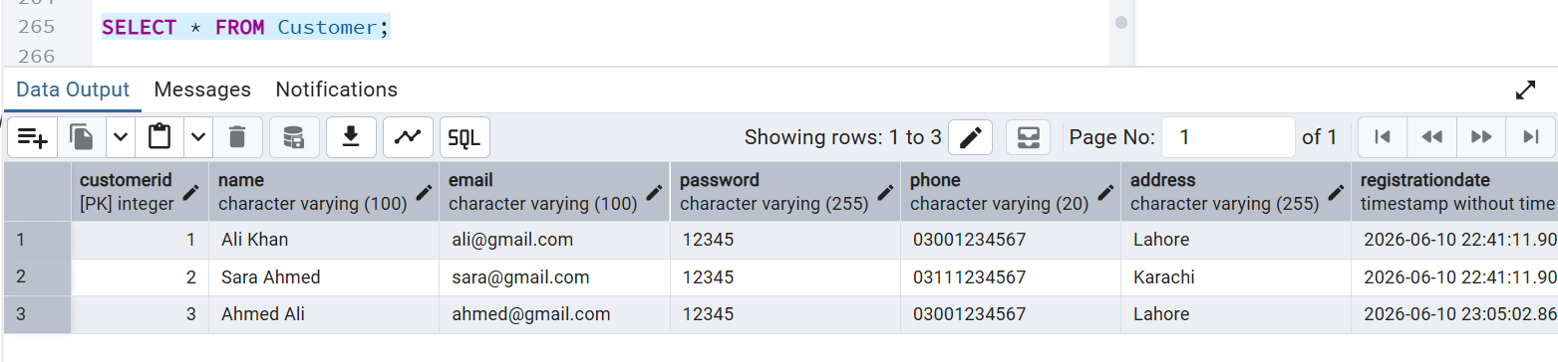

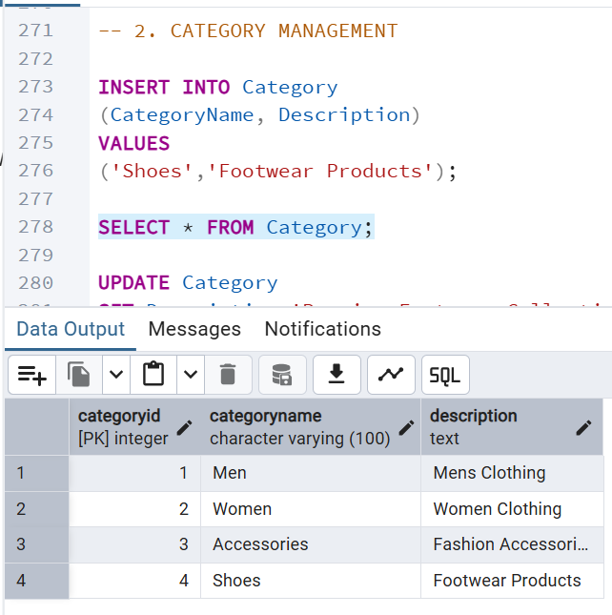

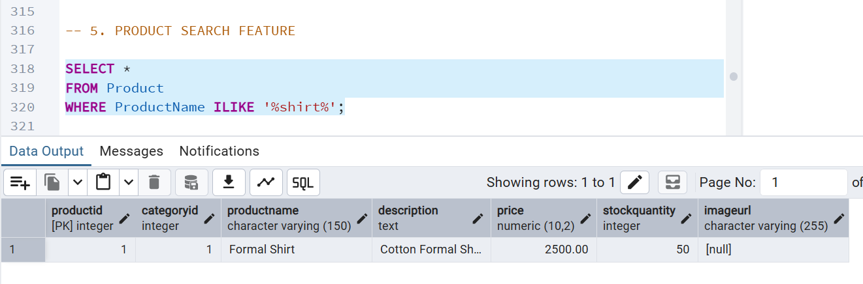
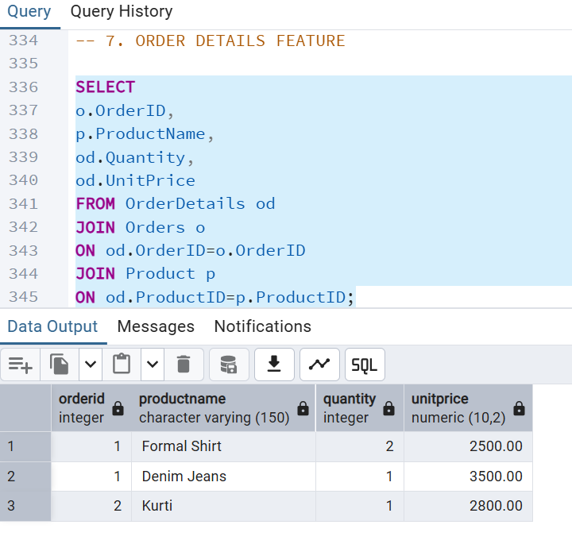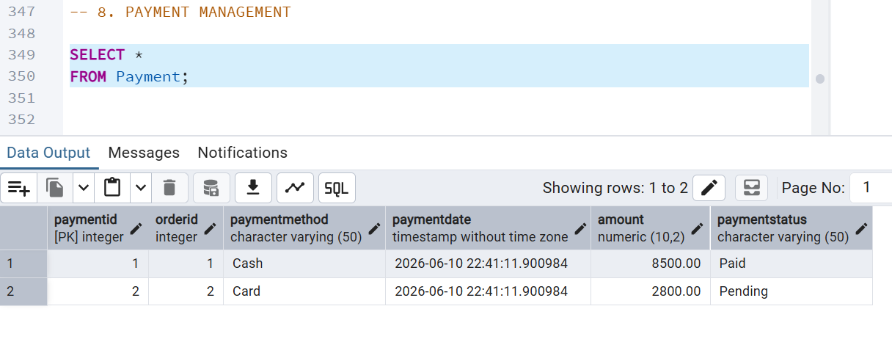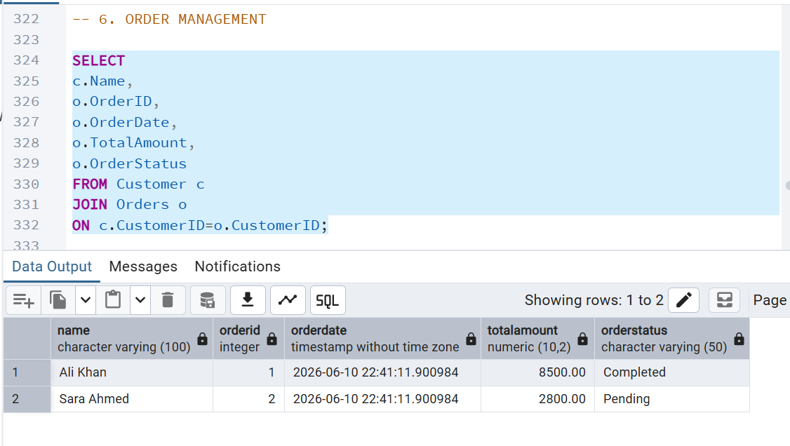

ER Diagram

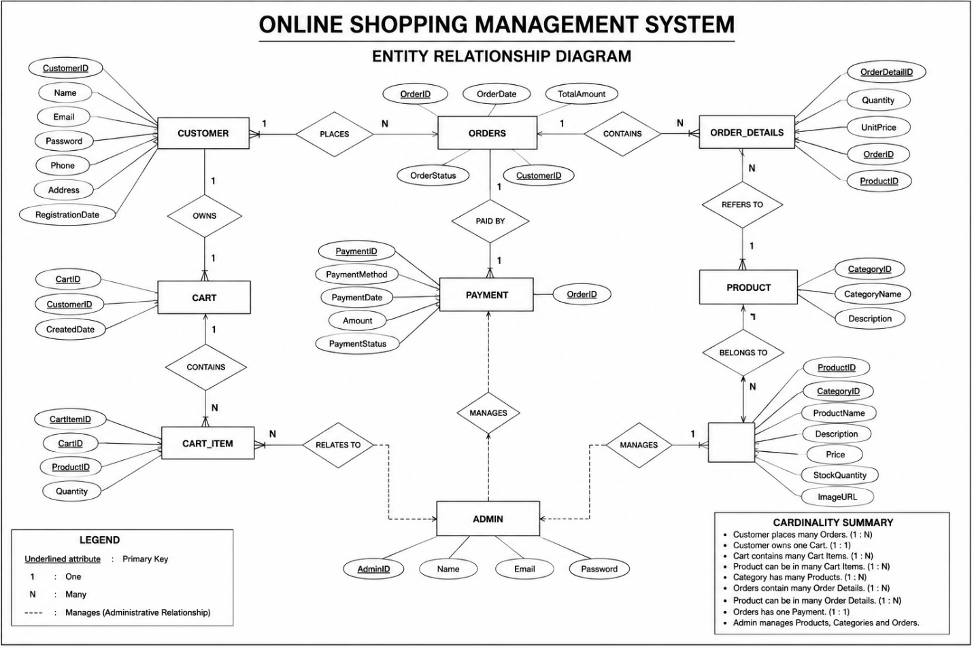
Rational Schema

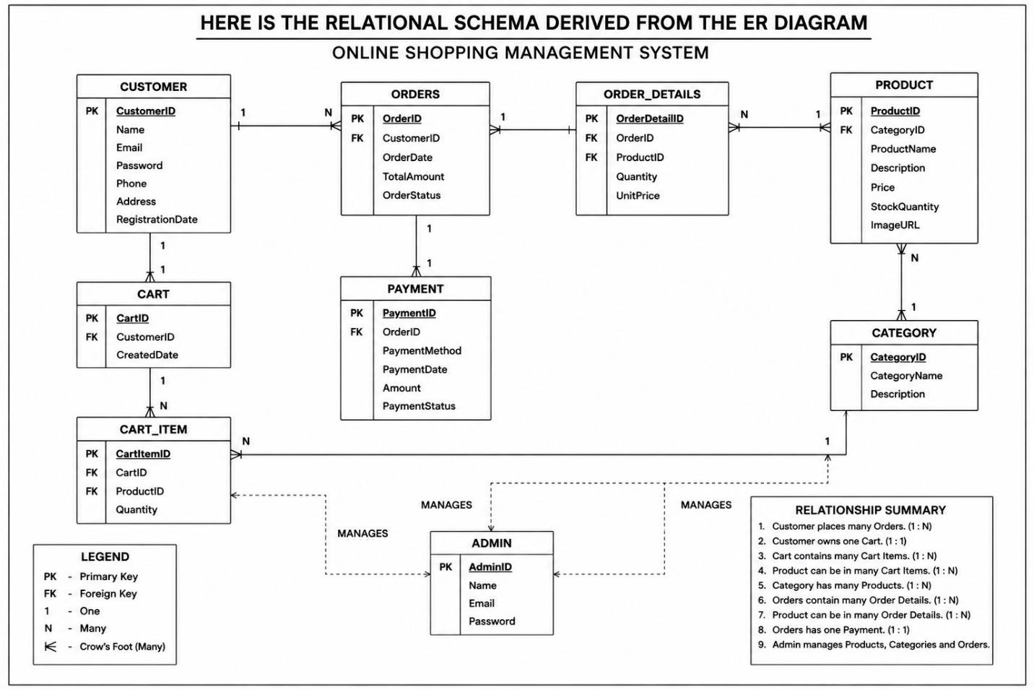

GitHub Repo Link
Abdurehman Khan:
https://github.com/70139031/DB-project.git

